**Project Design Phase-II**

**Data Flow Diagram & User Stories**

|  |  |
| --- | --- |
| Date | 25 June 2025 |
| Team ID | LTVIP2025TMID31802 |
| Project Name | Citizen AI |
| Maximum Marks | 4 Marks |

**Data Flow Diagrams:**

A Data Flow Diagram (DFD) is a traditional visual representation of the information flows within a system. A neat and clear DFD can depict the right amount of the system requirement graphically. It shows how data enters and leaves the system, what changes the information, and where data is stored.

- Citizens enter queries or feedback →  
- Queries go to the Chat Assistant (Granite Model) → AI Response displayed  
- Feedback is sent to Sentiment Analysis Engine →  
- Result is stored in CSV/JSON logs →  
- Dashboard retrieves and visualizes data →  
- Users can download logs

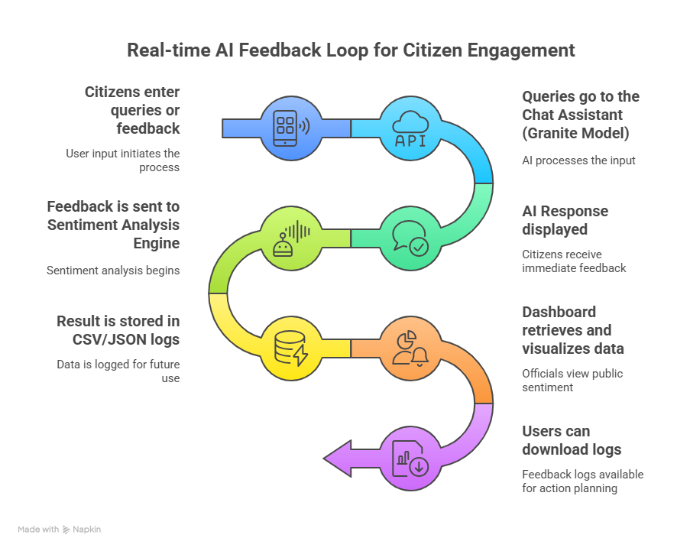

**User Stories**

Use the format below to list key user stories by user type.

|  |  |  |  |  |  |
| --- | --- | --- | --- | --- | --- |
| **User Type** | **Functional Requirement (Epic)** | **User Story Number** | **User Story / Task** | **Acceptance Criteria** | **Priority / Release** |
| Citizen | Chat Assistant | USN-1 | As a citizen, I can ask questions and receive AI responses in real time. | AI chatbot responds accurately | High / Sprint-1 |
| Citizen | Feedback System | USN-2 | As a citizen, I can submit feedback and see the sentiment classification. | Sentiment is displayed (Positive, Neutral, Negative) | High / Sprint-2 |
| Citizen | Dashboard Access | USN-3 | As a citizen, I can view sentiment trends via a dashboard. | Dashboard shows updated graphs | Medium / Sprint-2 |
| Official | Data Monitoring | USN-4 | As an official, I can download sentiment logs in CSV and JSON formats. | Files are generated and downloaded | Medium / Sprint-3 |
| System | Error Handling | USN-5 | As a system, I should show a warning when APIs fail or input is empty. | Warning messages appear | Low / Sprint-3 |